**SQL ASSIGNMENT**

Anurati Kulkarni

2237040

**MURDER MYSTERY**

A crime has taken place and the detective needs your help. The detective gave you the crime scene report, but you somehow lost it. You vaguely remember that the crime was a murder that occurred sometime on **Jan.15, 2018** and that it took place in **SQL City**. Start by retrieving the corresponding crime scene report from the police department’s database.

**SQL QUERIES**

1. SELECT * FROM crime_scene_report WHERE city = "SQL City" ORDER BY date;

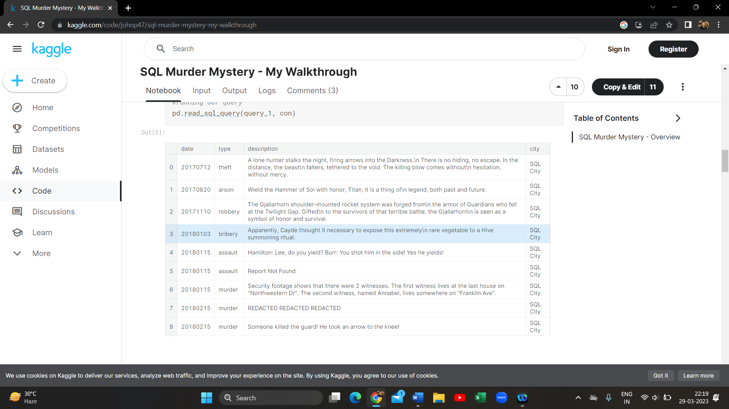

1. SELECT * FROM person WHERE address_street_name = "Northwestern Dr" ORDER BY address_number desc;

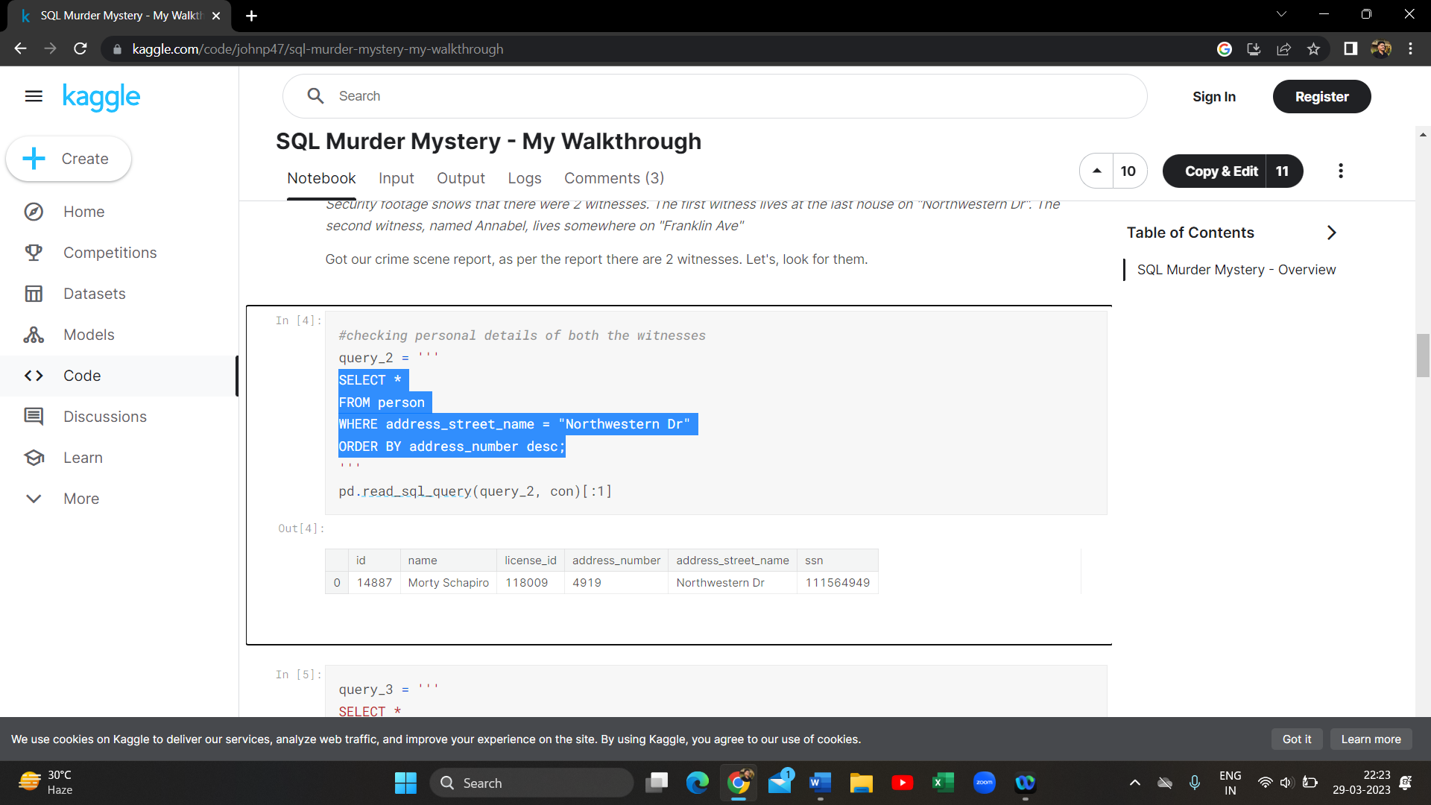

1. SELECT * FROM person WHERE name like '%Annabel%' AND address_street_name = "Franklin Ave";

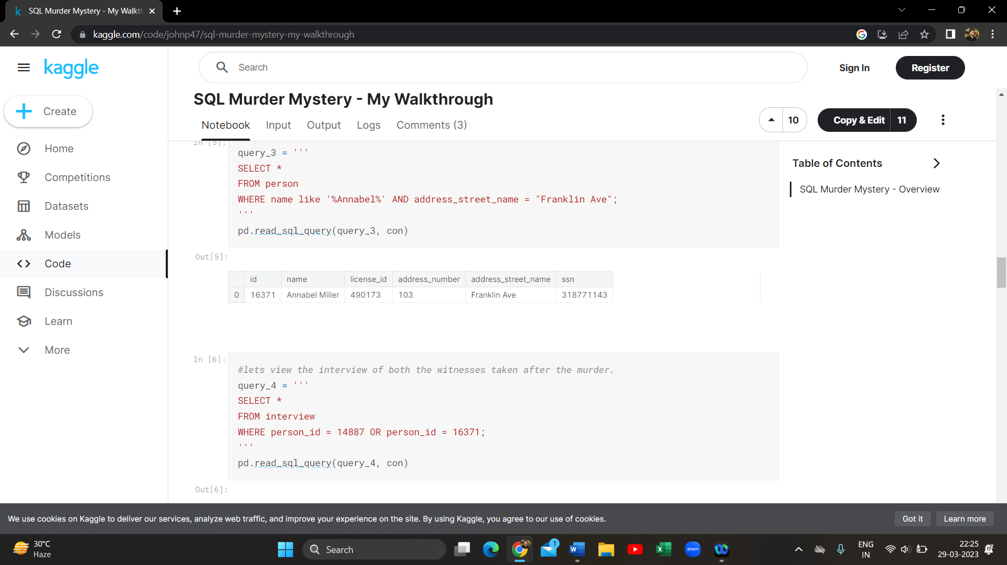

1. SELECT * FROM interview WHERE person_id = 14887 OR person_id = 16371;

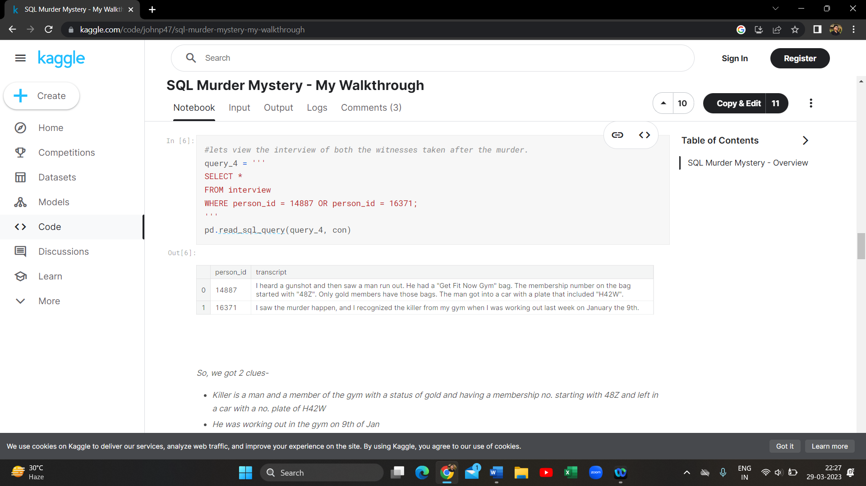

1. SELECT * FROM get_fit_now_check_in WHERE membership_id like "%48Z%" AND check_in_date = 20180109 order by check_in_date;

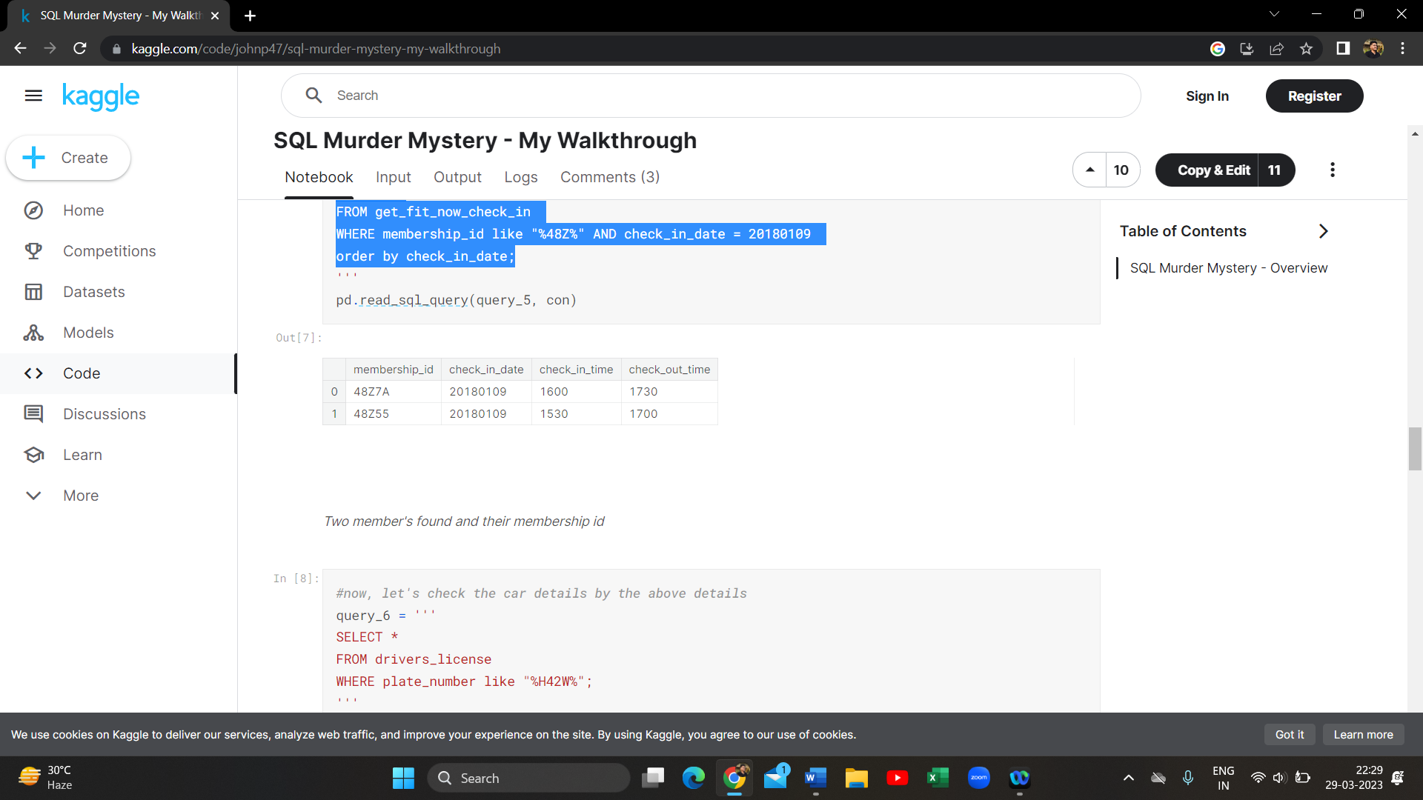

1. SELECT * FROM drivers_license WHERE plate_number like "%H42W%";

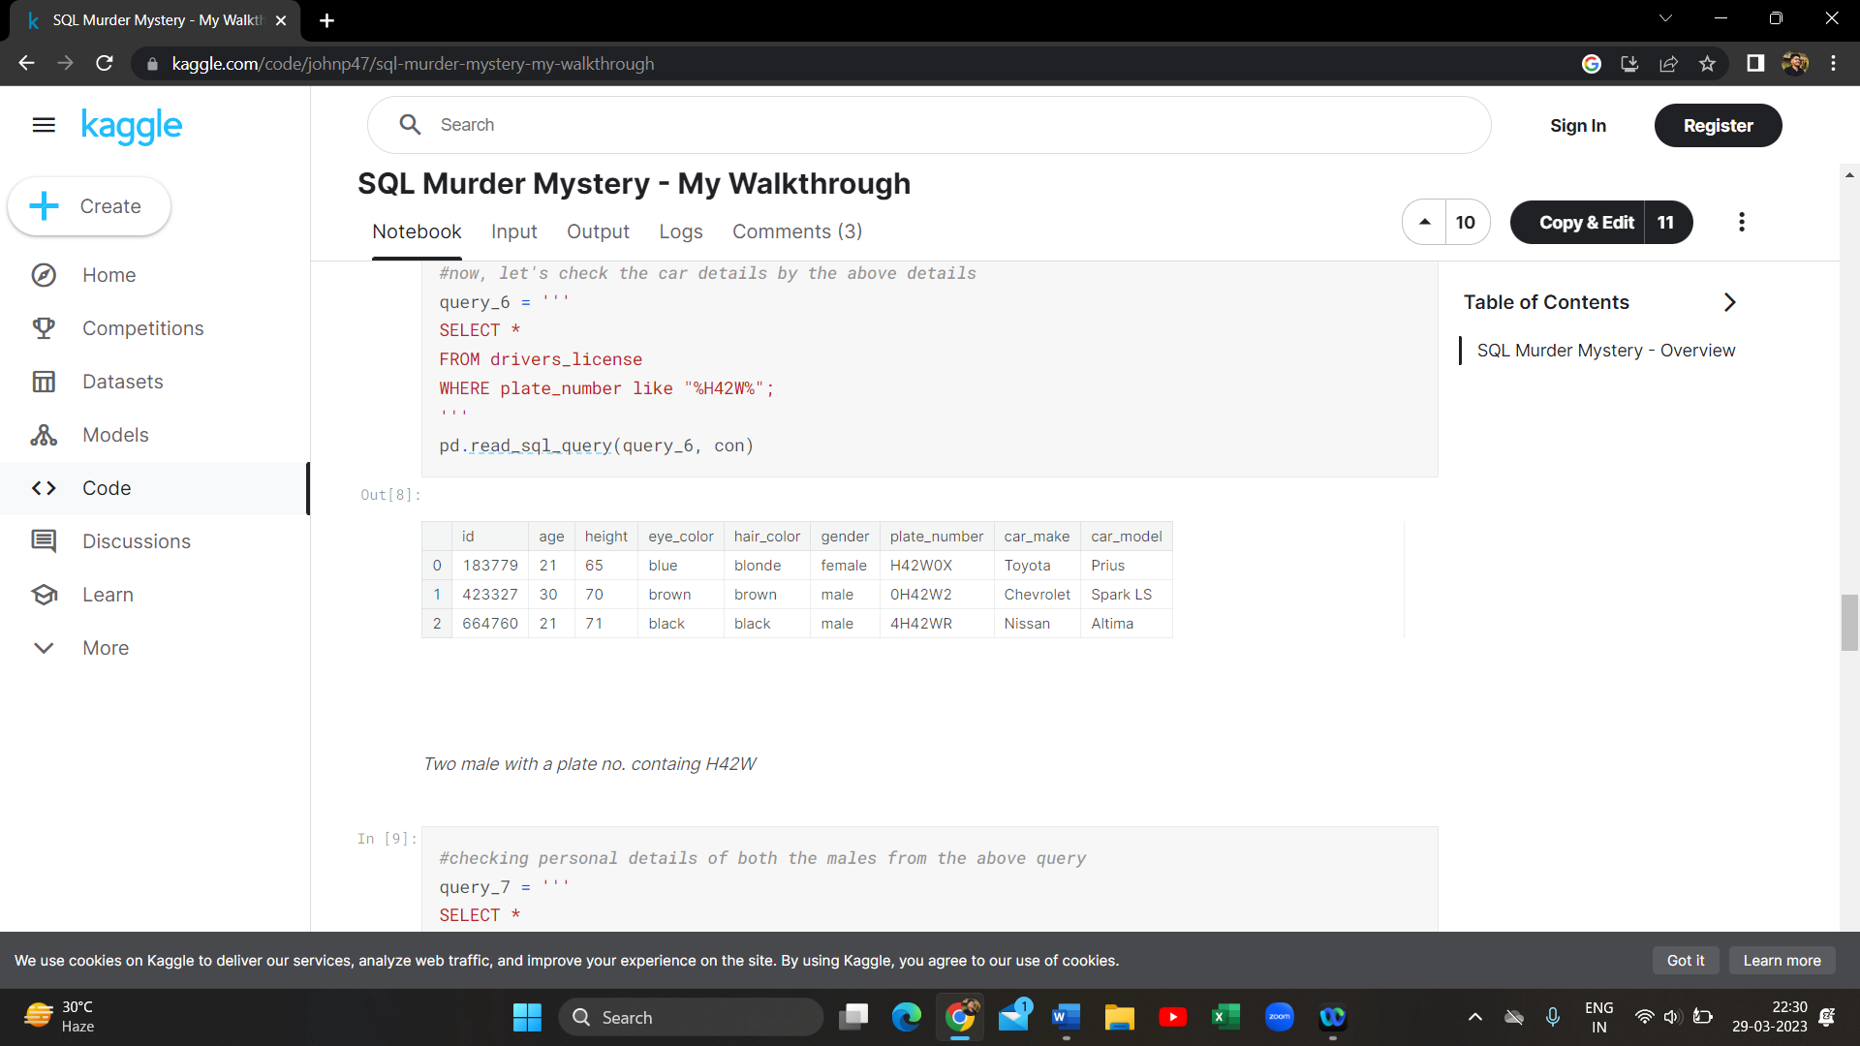

1. SELECT * FROM person WHERE license_id = "423327" OR license_id = "664760";

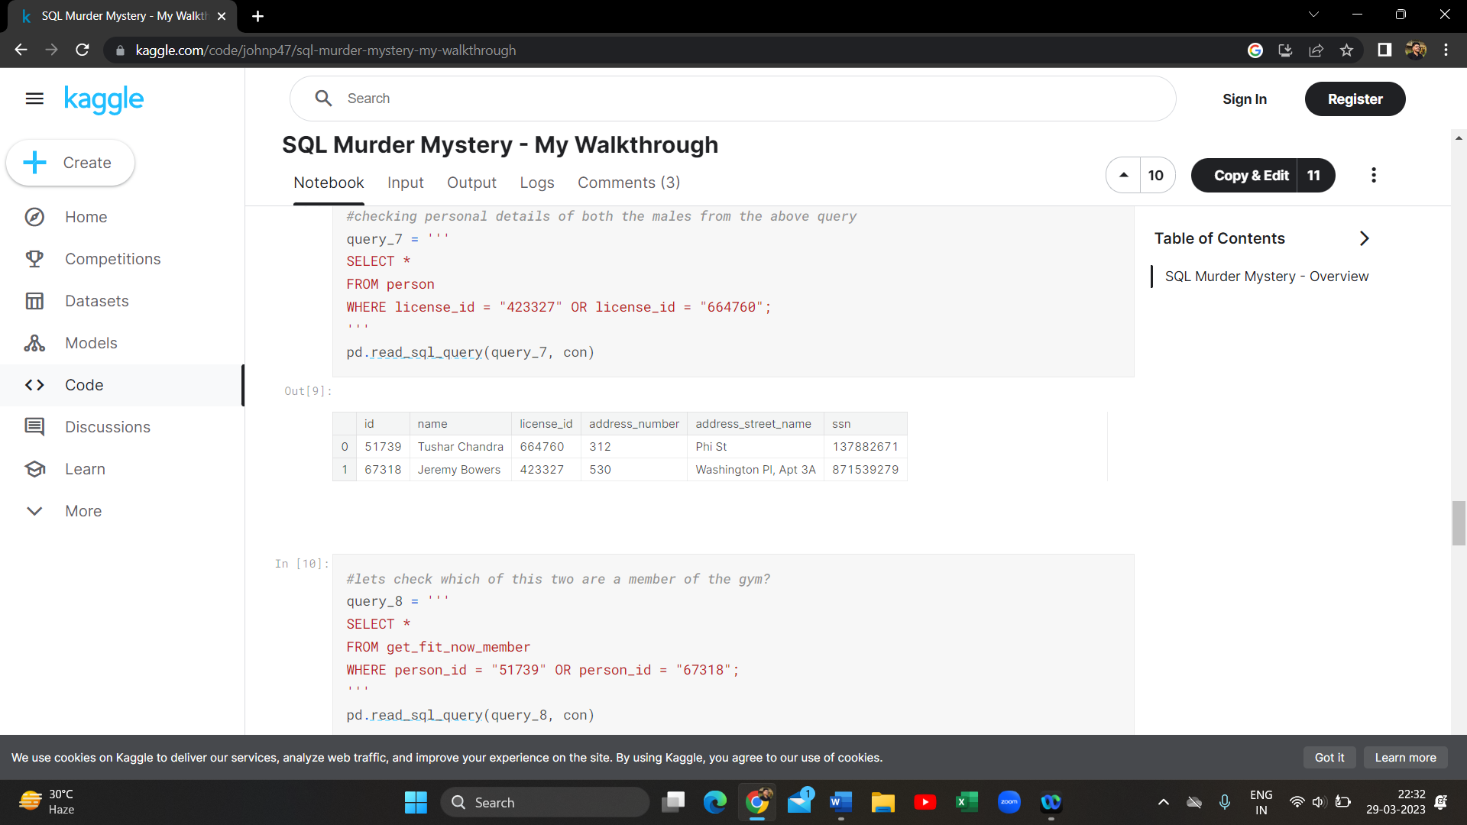

1. SELECT * FROM get_fit_now_member WHERE person_id = "51739" OR person_id = "67318";

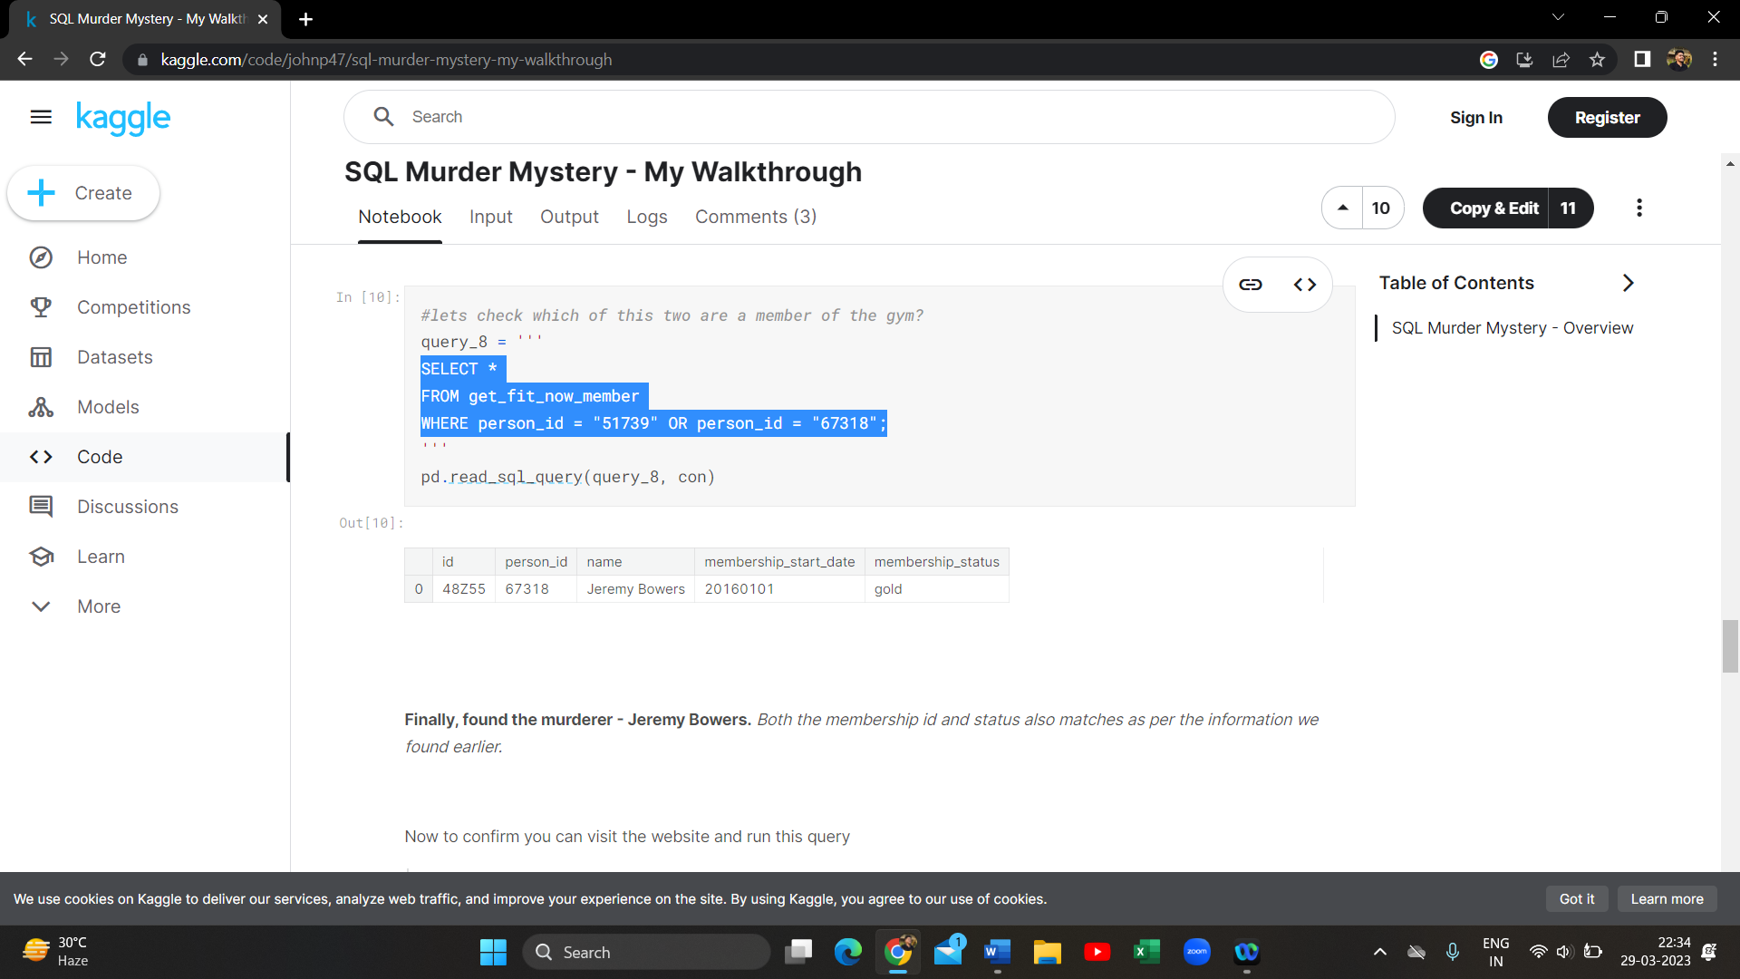

1. INSERT INTO solution VALUES (1, 'Jeremy Bowers');

SELECT value FROM solution;

